DI-3 & DI-2
Active Direct Injection Boxes/Signal Splitter (DI-2)
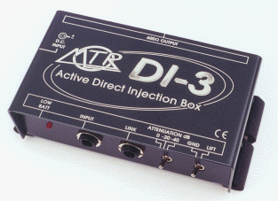
Quality direct boxes are hard to find in today's disposable marketplace - either quality products are too expensive or the economy version is too fragile. The excellent quality DI-3 single channel D.I. box has a mono jack input and link out socket, a ground lift to eliminate hum loops, a three position attenuator for accurate level matching, and a balanced 600 ohm XLR output. The active electronics have a purely resistive high input impedance, and so do not colour the sound. Both models can be powered in 3 ways: by a 9 volt battery, phantom power from the desk (or an MTR PPS-48), or an external 9v regulated power supply.
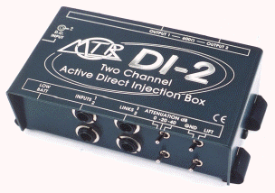
The DI-2 is a two channel version in the same sized box, for use with stereo keyboards or two separate mono signals. It can also be used as a balanced signal splitter by connecting a short jack-to-jack lead from the link socket of channel 1 to the input of channel 2. Channel 1's signal will then be available on both balanced XLR's, and channel 2's link socket. The attenuation switches remain working independently.
Specifications -
Freq. Res: 20Hz-20kHz ±3dB.
Distortion: (THD) < 0.005% at 1kHz, 0dBu
Output Noise: <-100dB unweighted
In/Link Impedance: 1MOhm, jack.
Output Impedance: 600 Ohms balanced XLR.
Atten. Switch: -40, -20, 0dB.
Ground Switch: Lifted/connected.
DC Input: 9vDC, 100mA, neg. centre pin
Phantom Power: +18 volts DC to +48 volts DC
‘Low Bat’ led: glows @ approx. 6v
Weight: 0.5Kg
"I have a number of the MTR active DI's, and the newest of them has given over 6 years trouble free service - the oldest is nearer 20" - Peter John Chivers http://www.stageboxsystems.co.uk
"Another happy user of MTR active DIs. Note these DIs do not have transformers in them, so they have an interesting set of tradeoffs; they have extended frequency response compared to lesser transformer equipped DIs, so bass gtr is not a problem. It also means they never truly ground lift, and it means they never get inductive coupling from the mains or output transformers of the amp they are sitting on. All that said, in practice, they work, and work well". - David Buckley. http://www.davidbuckley.name
"Thanks for a couple of excellent pieces of kit: just got two D1-2s to add to my DI-3: a 15-year old veteran that is still going strong! " - MikeWilloughby - melodeon, bouzouki, guitar, harmonica with Ceilidh band Striding Edge, www.striding-edge.org
"I have been using MTR DI boxes for over 10 years now with flawless performance and these dual passive ones are no exception. I have always found them to be well built. You get the feeling you could drop them from a lighting rig and they'd still work. The sound quality is also very good. The features are very user friendly with a ground lift, a -10dB and -20dB level reduction switch for hot signals and a link output for connecting a separate amp or monitor. The value of these are very good as well. I have used cheaper brands but the quality just isn't as good.
Reviewed By: Matt Rowbottom, c/o Absolute Music, Poole

